CS 342 Group 19

Rami Masoud (rmasou2)

Nathan Loo (nloo2)

Andrew Wirtz (awirtz5)

Aaron Lau (alau8)

Project Proposal - Bang!

Premise- (minimum) 4 player card game where each player is given a “role” or objective in the game, for example kill the outlaws and renegade (sheriff), be the last one standing (renegade), kill the sheriff (outlaw), or keep the sheriff alive (deputy/vice). The roles are dependent on the number of players. The vice isn’t always available in every game, but there is always one sheriff and one renegade in every game. These roles are to remain hidden from everyone, except the sheriff who reveals himself to everyone at the beginning of the game.

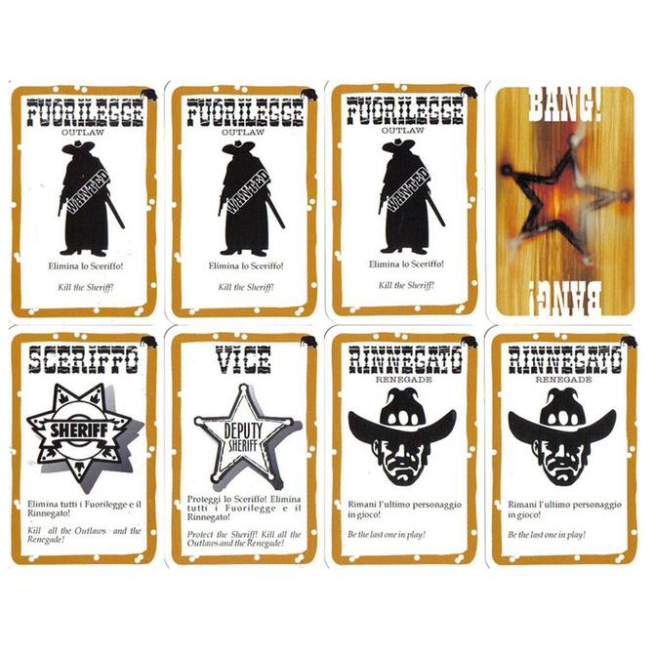

Each player will also get characters which each have unique abilities and varying amounts of health represented as bullets. The sheriff starts with one extra health.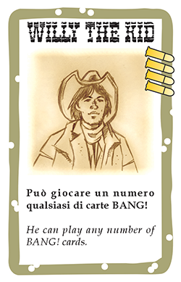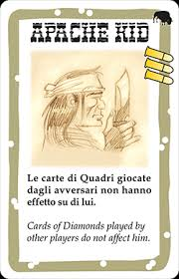

Players take turns by picking up 2 cards, each with different effects. The main cards are the Bangs and Misses. Bangs are used to damage a player while Misses cancel the effect of a Bang. If the player getting Banged doesn’t play a Miss, that player takes 1 damage. Each player may only use one Bang per turn.

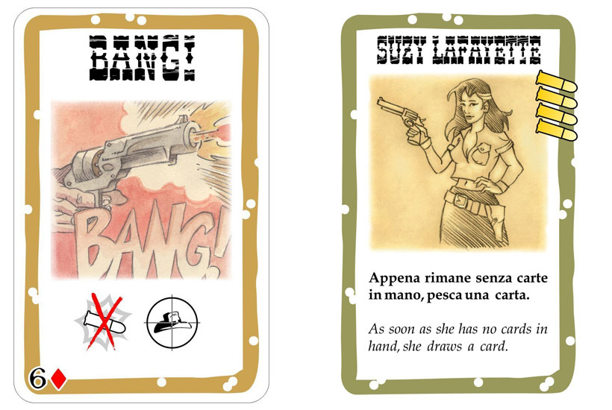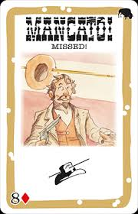

Each player has a distance that Bangs can be used. You can only Bang a player in range of you. This is calculated by how many seats the person is from you. The people sitting next to you have a range of 1, while those sitting next to them would have a range of 2 and so on. The player’s default range is 1 (can only hit the players next to them), but can be modified by certain cards like weapons

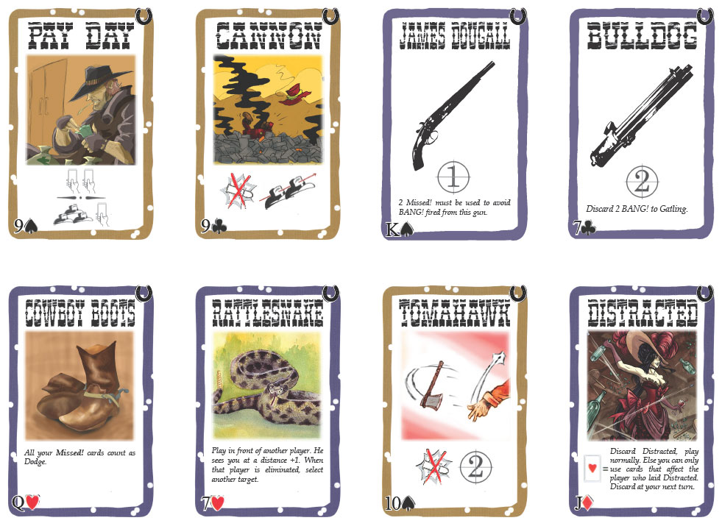

There are other cards that give which could give players some bonus, like increasing their range or restoring health. There’s no limit to how many cards can be played on a turn or how many cards of the same effect can be used, except Bang. At the end of a player’s turn, the player cannot have more cards than their current health. Example: a player that has 2 health remaining but 3 cards in hand at the end of their turn must get rid of one card. Weapons and other equipment do not count towards cards in your hand.

Once a character loses enough health, they die and reveal their role (if not a sheriff) to everyone. The game ends when the sheriff dies or is the last one standing (unless playing with vice in which case if the only people alive are the sheriff and vice). If the sheriff died and there is at least 2 people left alive, the outlaws win (even if the outlaws all died). If just the renegade is alive after the sheriff died, the renegade wins. If the sheriff manages to kill all outlaws and renegade, he wins.